## HTML is Not Case Sensitive

**# Syntax for html web page**

<!DOCTYPE html>

<html lang="en" dir="ltr">

<head>

<meta charset="utf-8">

<title></title>

</head>

<body>

</body>

</html>

The <!DOCTYPE> declaration represents the document type, and helps browsers to display web pages correctly.

The <!DOCTYPE> declaration is not case sensitive.

**# Comments in html**

We can assign comment in html using <!-- --> tags or simply we can use “ctrl + forward slash /” . For that select the paragraph or text to comment.

**# HTML Elements**

The HTML element is everything from the start tag to the end tag:

Syntax:

<tagname>Content goes here...</tagname>

**# Block Level elements**

 A Block-level element occupies the entire horizontal space of its parent element (container), and vertical space equal to the height of its contents, thereby creating a "block"

Browsers typically display the block-level element with a newline both before and after the element. So no need to pass break tag in between block level tags

A block-level element always starts on a new line and takes up the full width available (stretches out to the left and right as far as it can).

A block level element has a top and a bottom margin, whereas an inline element does not.

Check all block level elements list at:

<https://developer.mozilla.org/en-US/docs/Web/HTML/Block-level_elements>

**# Inline elements**

Inline elements are those which only occupy the space bounded by the tags defining the element.

An inline element does not start on a new line and only takes up as much width as necessary.

Check all inline elements list at:

<https://developer.mozilla.org/en-US/docs/Web/HTML/Inline_elements>

**# List of HTML elements**

|  |  |
| --- | --- |
| [<head>](https://developer.mozilla.org/en-US/docs/Web/HTML/Element/head) | The **HTML**<head>**element** contains machine-readable information (metadata) about the document, like its [title](https://developer.mozilla.org/en-US/docs/Web/HTML/Element/title), [scripts](https://developer.mozilla.org/en-US/docs/Web/HTML/Element/script), and [style sheets](https://developer.mozilla.org/en-US/docs/Web/HTML/Element/style) |
| <title> | The **HTML Title element** (<title>) defines the document's title that is shown in a Browser's title bar or a page's tab.  Both opening and closing tags are required. Note that leaving off </title> should cause the browser to ignore the rest of the page. |
| <body> | The **HTML**<body>**Element** represents the content of an HTML document. There can be only one <body> element in a document. |
| [<h1>](https://developer.mozilla.org/en-US/docs/Web/HTML/Element/Heading_Elements), [<h2>](https://developer.mozilla.org/en-US/docs/Web/HTML/Element/Heading_Elements), [<h3>](https://developer.mozilla.org/en-US/docs/Web/HTML/Element/Heading_Elements),  [<h4>](https://developer.mozilla.org/en-US/docs/Web/HTML/Element/Heading_Elements), [<h5>](https://developer.mozilla.org/en-US/docs/Web/HTML/Element/Heading_Elements), [<h6>](https://developer.mozilla.org/en-US/docs/Web/HTML/Element/Heading_Elements) | The **HTML**<h1>**–**<h6>**elements** represent six levels of section headings. <h1> is the highest section level and <h6> is the lowest. |
| [<p>](https://developer.mozilla.org/en-US/docs/Web/HTML/Element/p) | The **HTML**<p>**element** represents a paragraph |
| <b> | Defines bold text |
| <br> | Defines a single line break |
| <i> | The **HTML Idiomatic Text element** |
| <strong> | The HTML **Strong Importance Element** (<strong>) indicates that its contents have strong importance, seriousness, or urgency. It is replacement to <b> tag |
| <em> | Defines emphasized text , italic text, replacement for <i> tag |
| <li> | The **HTML**<li>**element** is used to represent each item in a list |
| <ol> | The **HTML**<ol>**element** represents an ordered list of items . both the starting and ending tag are mandatory. |
| <ul> | The **HTML**<ul>**element** represents an unordered list of items, typically rendered as a bulleted list. |
| <div> | Defines a section in a document. The <div> tag is easily styled by using the class or id attribute. |
| <span> | The <span> tag is an inline container used to mark up a part of a text, or a part of a document. |
| <img> | The **HTML**<img>**element** embeds an image into the document. |
| <mark> | Marked text |
| <small> | Smaller text |
| <del> | Deleted text |
| <ins> | Inserted text |
| <sup> | Superscript text |
| <sub> | Subscript text |
| <table> | The **HTML**<table>**element** represents tabular data |
| <thead> | The **HTML**<thead>**element** defines a set of rows defining the header row |
| <th> | Defines a header cell in a table (data in header rows) |
| <tr> | Defines a row in a table |
| <td> | Defines a cell in a table |

**# div element**

The <div> element is often used as a container for other HTML elements.

The <div> element has no required attributes, but style, class and id are common.

When used together with CSS, the <div> element can be used to style blocks of content:

e.g.

<!DOCTYPE html>

<html>

<body>

<div style="background-color:orange;color:white;padding:20px;">

<h2>London</h2>

<p>London is the capital city of England.</p>

<p>Standing on the River Thames</p>

</div>

</body>

</html>

o/p:

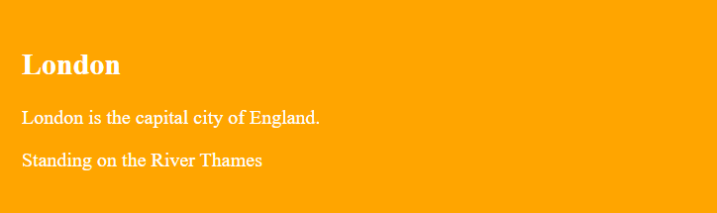

**# span element**

The <span> element is an inline container used to mark up a part of a text, or a part of a document.

The <span> element has no required attributes, but style, class and id are common.

When used together with CSS, the <span> element can be used to style parts of the text:

e.g.

<!DOCTYPE html>

<html>

<body>

<h1>The span element</h1>

<p>My mother has <span style="color:blue">blue</span> eyes and my father has <span style="color:green">dark green</span> eyes.</p>

</body>

</html>

o/p:

# The span element

My mother has blue eyes and my father has dark green eyes.

**# HTML Attributes**

* Attributes provide additional information about elements
* Attributes are always specified in the start tag
* Attributes usually come in name/value pairs like: name="value"

**# HTML class Attribute**

The HTML class attribute is used to specify a class for an HTML element.

Multiple HTML elements can share the same class. The class attribute is often used to point to a class name in a style sheet.

To create a class; write a period (.) character, followed by a class name. Then, define the CSS properties within curly braces {}:

e.g.

<!DOCTYPE html>

<html>

<head>

<style>

.city {

background-color: tomato;

color: white;

margin: 20px;

padding: 20px;

}

</style>

</head>

<body>

<div class="city">

<h2>London</h2>

<p>London is the capital of England.</p>

</div>

<div class="city">

<h2>Paris</h2>

<p>Paris is the capital of France.</p>

</div>

</body>

</html>

o/p:

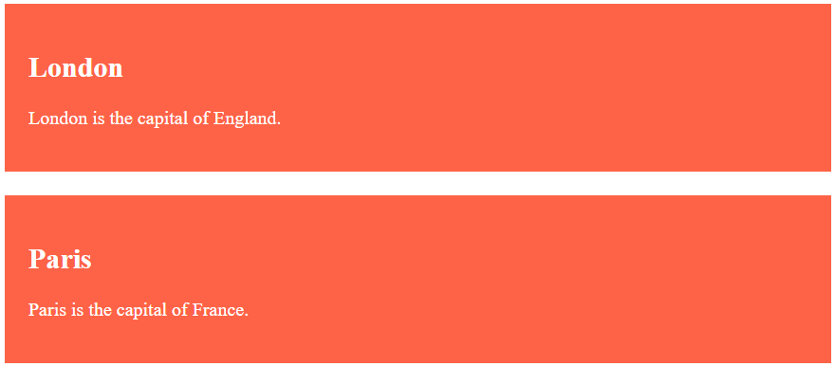

**Multiple Classes**

Single HTML elements can belong to more than one class. To define multiple classes, separate the class names with a space. e.g. <div class="city main">

Here city and main are two class names

e.g.

<!DOCTYPE html>

<html>

<head>

<style>

.city {

background-color: tomato;

color: white;

padding: 10px;

}

.main {

text-align: center;

}

</style>

</head>

<body>

<h2>Multiple Classes</h2>

<p>Here, all three h2 elements belongs to the "city" class. In addition, London also belongs to the "main" class, which center-aligns the text.</p>

<h2 class="city main">London</h2>

<h2 class="city">Paris</h2>

</body>

</html>

o/p:

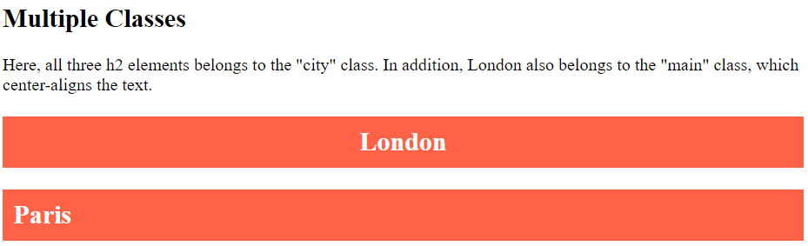

**# HTML id Attribute**

The HTML id attribute is used to specify a unique id for an HTML element.

We cannot have more than one element with the same id in an HTML document.

The syntax for id is: write a hash character (#), followed by an id name. Then, define the CSS properties within curly braces {}.

e.g.

<!DOCTYPE html>

<html>

<head>

<style>

#myHeader {

background-color: lightblue;

color: black;

padding: 40px;

text-align: center;

}

</style>

</head>

<body>

<h2>The id Attribute</h2>

<p>Use CSS to style an element with the id "myHeader":</p>

<h1 id="myHeader">My Header</h1>

</body>

</html>

o/p:

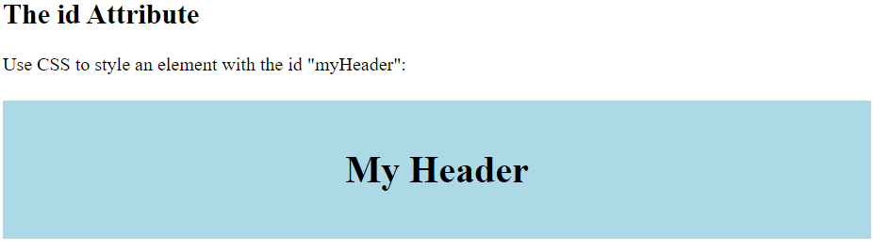

**# HTML Tables**

HTML tables allow web developers to arrange data into rows and columns.

Table is defined by HTML’s table tag, each row is defined by tr tag, data in each row (except header row) is defined by td tag, header row is defined by thead tag and data in header row is defined by th tag.

Syntax:

<table>

<thead>

<th> </th>

</thead>

<tr>

<td></td>

</tr>

</table>

**# Head Tag in HTML**

The <head> element is a container for metadata (data about data). HTML metadata is data about the HTML document. Metadata is not displayed.

Metadata typically define the document title, character set, styles, scripts, and other meta information.

* The HTML <title> Element

The <title> element defines the title of the document.

The <title> element:

* defines a title in the browser toolbar
* provides a title for the page when it is added to favorites
* displays a title for the page in search engine-results
* The HTML <link> Element

The <link> element defines the relationship between the current document and an external resource.  
The <link> tag is most often used to link to external style sheets:

* The HTML <meta> Element
  + The <meta> element is typically used to specify the character set, page description, keywords, author of the document, and viewport settings.
  + The metadata will not be displayed on the page, but are used by browsers (how to display content or reload page), by search engines (uses keywords), and other web services.
  + **Examples**
    - Define the character set used:

<meta charset="UTF-8">

* + - Define keywords for search engines:

<meta name="keywords" content="HTML, CSS, JavaScript">

* + - Define a description of your web page:

<meta name="description" content="Free Web tutorials">

* + - Define the author of a page:

<meta name="author" content="John Doe">

* + - Refresh document every 30 seconds:

<meta http-equiv="refresh" content="30">

* The HTML <script> Element
  + The <script> element is used to define client-side JavaScripts.
* The HTML <base> Element
  + The <base> element specifies the base URL and/or target for all relative URLs in a page. Means any url in webpage will work relative to base url.
    - <base href="https://www.w3schools.com/" target="_blank">

We can set the viewport to make your website look good on all devices:

<meta name="viewport" content="width=device-width, initial-scale=1.0">

This gives the browser instructions on how to control the page's dimensions and scaling.

The width=device-width part sets the width of the page to follow the screen-width of the device (which will vary depending on the device).

The initial-scale=1.0 part sets the initial zoom level when the page is first loaded by the browser.